# Media Analysis - AI is not smarter than humans

## Short Summary

The article delves into ChatGPT, its widespread AI applications, examines past misuse concerns similar to Tay's racist incident, underscores AI's expanding presence in personal and professional domains, acknowledges technology limitations including cultural understanding, and stresses the significance of human interaction alongside technological progress.

## Summary

1. AI tools like ChatGPT can significantly enhance personal life and business tasks through their usefulness in communicating, brainstorming ideas, and even acting as recruiters or CEOs.  
2. The creation of Siri by Apple in 2011 marked a significant advancement where users can now have virtual assistants for reminders, alarms, and various personal tasks.  
3. AI's potential is immense, enabling humans to communicate more freely by overcoming language barriers with tools like Google Translate.  
4. While AI provides benefits such as simplifying workloads and generating innovative ideas, it cannot replicate human connection or understanding of nuanced cultural contexts.  
5. The example of Tay, a chatbot released by Microsoft that was corrupted into spewing offensive messages due to negative user input, highlights the risks associated with AI, particularly its reliability and ability to understand context in a human-like manner.  
6. As technology evolves, AI's role is revolutionizing business operations and marketing efforts, but it will never fully replace the unique value that humans bring in creating personalized messaging or understanding cultural nuances.  
7. The article emphasizes that AI tools are powerful companions to human creativity rather than replacements, underscoring the evolving relationship between humans and artificial intelligence as a force for good in society.

## Question 1:

How do the media in this article frame the public discussion about ChatGPT? Are there certain **metaphors** that keep cropping up?

AI can become a powerful force, yet it is still in its infancy The tale of Tay serves as an example Within just 16 hours of being released on Twitter by Microsoft, the chatbot had been corrupted into spewing racist messages due to all the negative input it received from users. With the increasing influence of AI in our lives, there are many questions about how it will shape our future, from its utilization to aspects like reliability and connection with humans.

## Question 2:

Which role does or might the Arabic World play in the development of Artificial Intelligence? Answer with 'Not mentioned' if not applicable.

Not mentioned

## Question 3:

Which use cases of Artificial Intelligence are helpful for the Arabic world based on this article?

1. Personal tasks and business operations Virtual assistants like ChatGPT that help with daily tasks and marketing campaigns. 2. Language translation capabilities AI tools aiding communication across languages like English and Arabic. 3. Global connection Enhancing international collaboration and understanding.

## Question 4:

What is the final message of the article that the author wants to convey? Keep your answer short and precise!

The author advocates for responsible use of AI, highlighting its potential benefits through personal anecdotes but acknowledging concerns about reliability. He asserts that while AI can augment human skills, it cannot replace essential human connections and emphasizes the importance of maintaining a balanced perspective.

## Sentiment

The sentiment is <3>

The sentiment towards AI in this article ranges from neutral to positive, highlighting both its capabilities and limitations. The author uses specific examples, such as Tay's failure on Twitter and Siri's assistance, to illustrate their points. They express concern about the potential risks of AI, particularly when it malfunctions or reflects human biases, but also emphasize the technology's potential for good in areas like marketing and personal communication. The author acknowledges that while AI can be helpful, it cannot fully replace human interaction and understanding. Therefore, based on this analysis, I would assign a sentiment score of 3.

## Entities

Saint Mary University, Ali Al Mustafa Main Image Ai Smart, National Anthem Look Flag, Grace Business Operation Marketing Department Include Computer Understand Like Culture, Offer Simple, Real Life Recruiter Marketer, Https Medium Arab News Country, Ali Al Mustafa, Kid Singe

## Topic Clusters

### Cluster: AI Capabilities and Virtual Assistants

Introduction to ChatGPT, ChatGPT's text generation abilities, Applications of ChatGPT in various fields

### Cluster: Human-AI Relationship

Societal impacts of AI, Ethical considerations in AI development, Public perception of AI

## Word Clouds

### Wordcloud of content

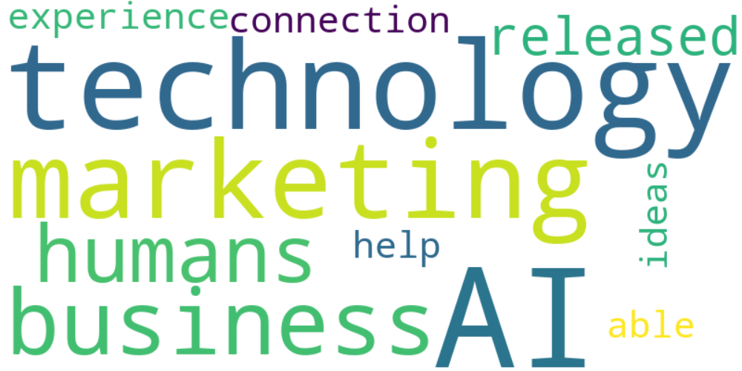

Top 10 words:

- AI: 10  
- technology: 8  
- marketing: 6  
- like: 5  
- business: 4  
- humans: 3  
- released: 3  
- experience: 3  
- able: 3  
- ideas: 3

### Wordcloud of summary

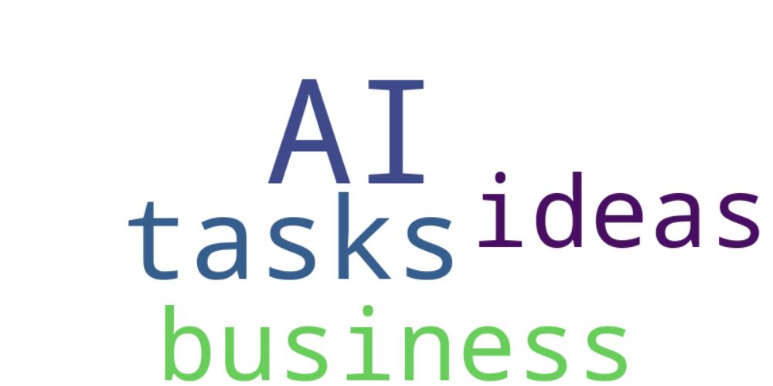

Top 10 words:

- AI: 6  
- tools: 3  
- like: 3  
- humans: 3  
- human: 3